

UWA Placement Induction Program

The placement induction program is designed to help you make the most of your placement experience and keep you safe in the workplace.

As an intern or volunteer, you will be acting as representatives of UWA, and you are required to demonstrate you have the knowledge outlined in this program in order to have access to UWA insurances. The three modules will provide you with information and guidance to ensure you are able to perform your role **safely** and **professionally** whilst building transferable skills.

**NOTE:** If you have completed the ‘Pre-Placement Modules’ previously, for McCusker or a unit, there is no need to repeat the process. Please upload your existing ‘Pre- Placement Module’ certificate to the corresponding SONIA check.

**INSTRUCTIONS- HOW TO ENROL:**

* Login to the LMS using your Pheme account details [www.lms.uwa.edu.au](http://www.lms.uwa.edu.au/)
* Copy the following link and paste it into the URL bar of your browser https://lms.uwa.edu.au/ultra/organizations/_100775_1/outline then press the **[Return]** key.
* On the self-enrolment page, click ‘Submit’ bottom right **to enrol – see below**

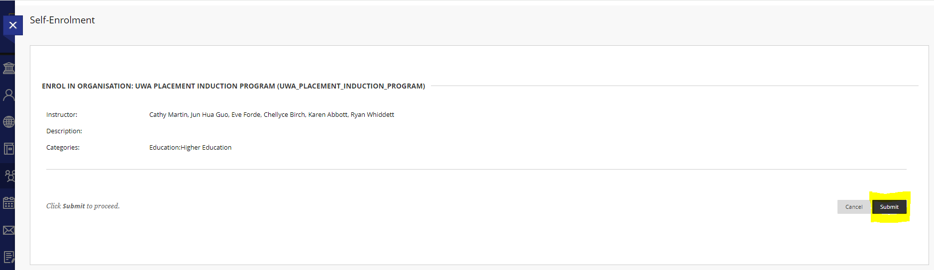

**HOW TO COMPLETE THE PROGRAM:**

* All three modules in this unit take between 2.5 - 4 hours to complete. Please ensure you budget enough time to complete these.
* When you open the link, you will see a navigation bar as displayed below to help you manoeuvre through the program.

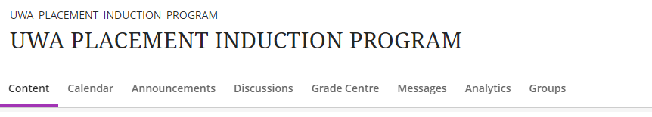

* To begin, click on *Content* and click on *UWA Placement Induction Program* to carefully read the *Welcome to UWA Placement Induction Program*
* To access the modules, simply scroll down to the *Content* page. The modules are:

1. *Pre-Placement: Preparing for your Placement.*
2. *On Placement: Maximising your experience.*
3. *Post-Placement: Utilising your learnings.*

* Each module contains information to help you complete the quizzes at the end of each module. These quizzes consist of multiple-choice questions, and **you must complete each quiz with 100% grade.**
* Once you have completed each quiz, look at the navigation bar again and click on *Grade Centre*. Here, you can see if you have received 200/200 (100%) overall grade.
* Each quiz provides you with feedback after submission. Please review this feedback *carefully* before reattempting any quiz.
* If you noticed you need to retake a quiz, you can click on the chosen quiz here to redo.

**HOW TO SHOW YOUR PLACEMENT INDUCTION PROGRAM IS COMPLETED:**

* When you have received 100% grades in each quiz, please take a screen shot of the *Grade Centre* page exactly as displayed below: **(you must include your student name in the screenshot for verification purposes).**
* Then log into your SONIA account, click on the ‘Checks’ tab and upload your screenshot to the Placement Induction Program check.

